Phase 01 : Get started with the we development

**Simply Blogging**

**Project 1**

DESCRIPTION

As a Full Stack Developer, you have to develop a blog for the company where people can post articles and customers can benefit from the content.

Have used almost all the concepts which were taught in the phase 01 session.

Here is the github repository link

<https://github.com/muskanrafeeq04/phase1-/tree/main>

all the task, source code, images everything has been tracked in the github link.

I have created a company website where we can find the article of any topic,

**The website has not been connected with a backend database.**

***ScreenShots of the website***

**First Starting Index page**

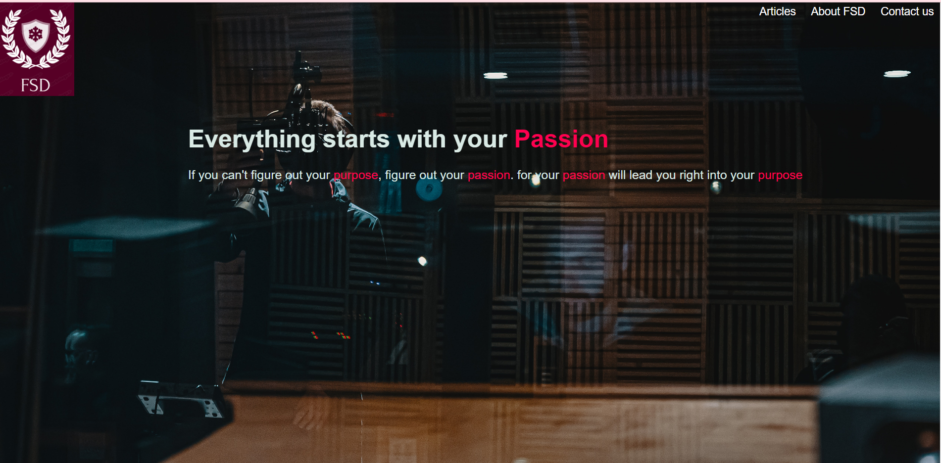

**Articles with the hover effect**

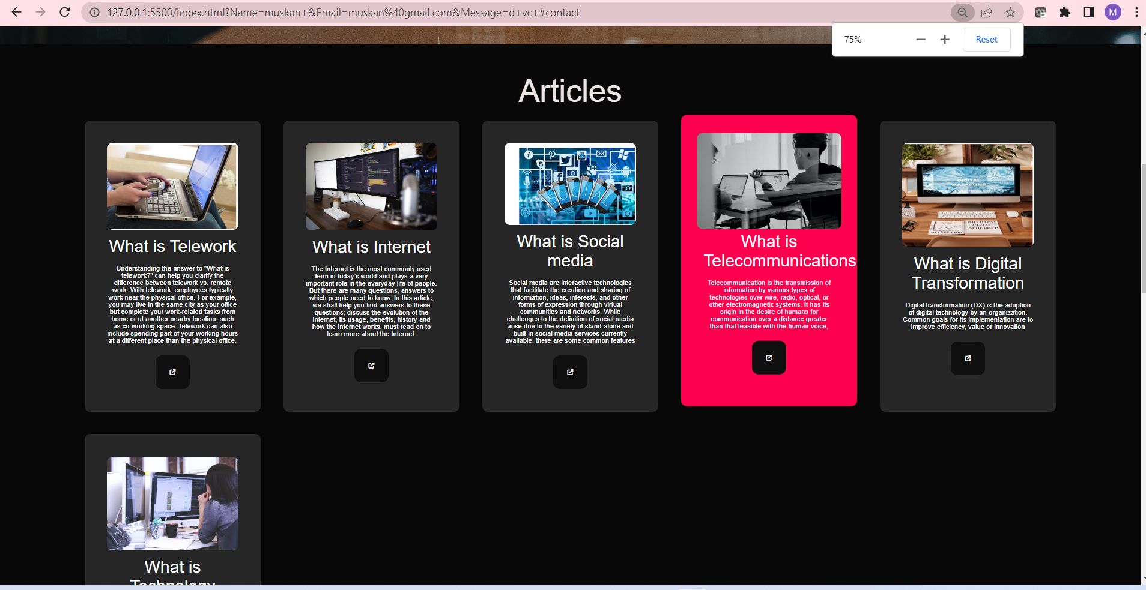

**About FSD**

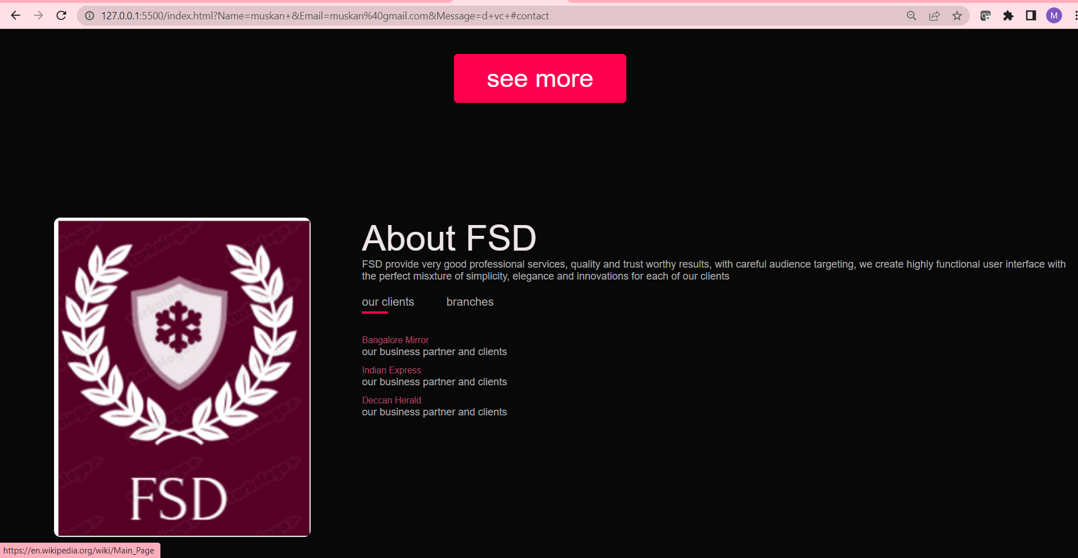

**Contact us page**

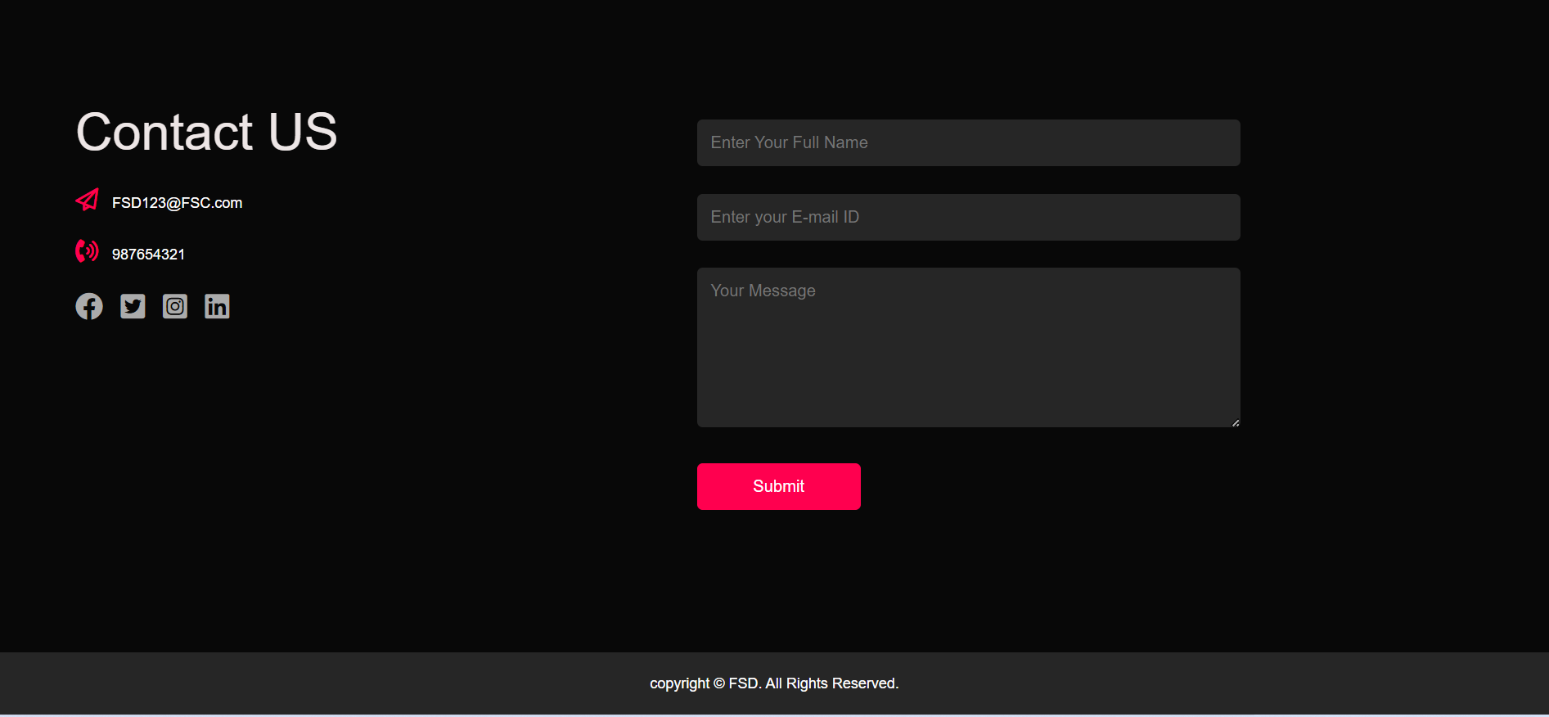

**Responsive web page**

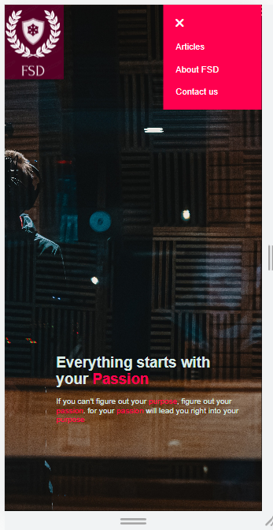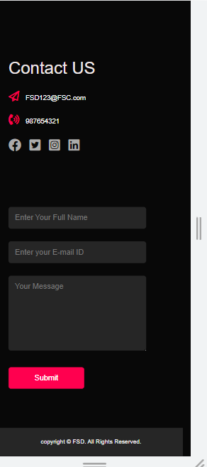

**Source Code**

**Index.html:**

**<!DOCTYPE html>**

**<html lang="en">**

**<head>**

**<meta charset="UTF-8">**

**<meta http-equiv="X-UA-Compatible" content="IE=edge">**

**<meta name="viewport" content="width=device-width, initial-scale=1.0">**

**<title>FSD company blog</title>**

**<link rel="stylesheet" href="style.css">**

**<script src="https://kit.fontawesome.com/9bf0a5ee3a.js" crossorigin="anonymous"></script>**

**</head>**

**<body>**

**<div id="header">**

**<div class="container">**

**<nav>**

**<img src="images/logo1.png" class="logo">**

**<ul id="sidemenu">**

**<li><a href="articles.html" target="_blank" >Articles</a></li>**

**<li><a href="#about">About FSD</a></li>**

**<li><a href="#contact">Contact us</a></li>**

**<i class="fas fa-sharp fa-solid fa-xmark" onclick="closemenu()"></i>**

**</ul>**

**<i class="fas fa-solid fa-bars" onclick="openmenu()"></i>**

**</nav>**

**<div class="header-text">**

**<h1><br>Everything starts with your <span>Passion</span></h1><br>**

**<p>If you can't figure out your <span>purpose</span>, figure out your <span>passion</span>.**

**for your <span>passion</span> will lead you right into your <span>purpose</span></p>**

**</div>**

**</div>**

**</div>**

**<!-- article -->**

**<div id="article">**

**<div class="container">**

**<h1 class="sub-title">Articles</h1>**

**<div class="article-list">**

**<div class="arts">**

**<img src="images/telework.jpg">**

**<br><h2>What is Telework</h2>**

**<p>Understanding the answer to "What is telework?" can help you clarify the difference between telework vs. remote work. With telework, employees typically work near the physical office. For example, you may live in the same city as your office but complete your work-related tasks from home or at another nearby location, such as co-working space. Telework can also include spending part of your working hours at a different place than the physical office.</p>**

**<a href="https://www.telework.gov/federal-community/telework-employees/telework-basics/"> <i class="fa-sharp fa-solid fa-up-right-from-square"></i></a>**

**</div>**

**<div class="arts">**

**<img src="images/cloud computing.jpg">**

**<br> <h2>What is Internet</h2>**

**<p>The Internet is the most commonly used term in today’s world and plays a very important role in the everyday life of people. But there are many questions, answers to which people need to know. In this article, we shall help you find answers to these questions; discuss the evolution of the Internet, its usage, benefits, history and how the Internet works.**

**must read on to learn more about the Internet. </p>**

**<a href="https://en.wikipedia.org/wiki/Internet" target="_blank"> <i class="fa-sharp fa-solid fa-up-right-from-square"></i></a>**

**</div>**

**<div class="arts">**

**<img src="images/internet.jpg">**

**<br> <h2>What is Social media</h2>**

**<p>Social media are interactive technologies that facilitate the creation and sharing of information, ideas, interests, and other forms of expression through virtual communities and networks. While challenges to the definition of social media arise due to the variety of stand-alone and built-in social media services currently available, there are some common features </p>**

**<a href="https://en.wikipedia.org/wiki/Social_media" target="_blank"> <i class="fa-sharp fa-solid fa-up-right-from-square"></i></a>**

**</div>**

**<div class="arts">**

**<img src="images/consulting.jpg">**

**<br> <h2>What is Telecommunications</h2>**

**<p>Telecommunication is the transmission of information by various types of technologies over wire, radio, optical, or other electromagnetic systems. It has its origin in the desire of humans for communication over a distance greater than that feasible with the human voice, </p>**

**<a href="https://en.wikipedia.org/wiki/Telecommunications" target="_blank"> <i class="fa-sharp fa-solid fa-up-right-from-square"></i></a>**

**</div>**

**<div class="arts">**

**<img src="images/digital marketing.jpg">**

**<br> <h2>What is Digital Transformation </h2>**

**<p>Digital transformation (DX) is the adoption of digital technology by an organization. Common goals for its implementation are to improve efficiency, value or innovation </p>**

**<a href="https://en.wikipedia.org/wiki/Digital_transformation" target="_blank"> <i class="fa-sharp fa-solid fa-up-right-from-square"></i></a>**

**</div>**

**<div class="arts">**

**<img src="images/tech.jpg">**

**<br><h2>What is Technology</h2>**

**<p>Technologies are artifacts made through a systematic application of knowledge and used to reach practical goals. They are widely used in medicine, science, industry, communication, transportation, and daily life. Technologies include physical objects like utensils or machines, as well as intangible tools like software. </p>**

**<a href="https://en.wikipedia.org/wiki/Technology" target="_blank"> <i class="fa-sharp fa-solid fa-up-right-from-square"></i></a>**

**</div>**

**</div>**

**<a href="https://en.wikipedia.org/wiki/Main_Page" target="_blank" class="btn">see more</a>**

**</div>**

**</div>**

**<!-- end of article -->**

**<!-- about -->**

**<div id="about">**

**<div class="container">**

**<div class="row">**

**<div class="about-col-1">**

**<img src="images/logo2.png">**

**</div>**

**<div class="about-col-2">**

**<h1 class="sub-title">About FSD</h1>**

**<p >FSD provide very good professional services, quality and trust worthy results, with careful audience targeting, we create highly functional user interface with the perfect mixture of simplicity, elegance and innovations for each of our clients</p>**

**<div class="tab-titles">**

**<p class="tab-links active-link" onclick="opentab('ourclients')">our clients</p>**

**<p class="tab-links" onclick="opentab('branch')">branches</p>**

**</div>**

**<div class="tab-contents active-tab" id="ourclients">**

**<ul>**

**<li><span>Bangalore Mirror</span><br>our business partner and clients</li>**

**<li><span>Indian Express</span><br>our business partner and clients</li>**

**<li><span>Deccan Herald</span><br>our business partner and clients</li>**

**</ul>**

**</div>**

**<div class="tab-contents" id="branch">**

**<ul>**

**<li><span>Bangalore</span><br>2 branch located with Head office is located in Bangalore</li>**

**<li><span>Chennai</span><br>4 branches located in chennai</li>**

**<li><span>Maharashtra</span><br>5 branches located in Maharashtra</li>**

**</ul>**

**</div>**

**</div>**

**</div>**

**</div>**

**</div>**

**</div>**

**<!-- contact us -->**

**<div id="contact">**

**<div class="container">**

**<div class="row">**

**<div class="contact-left">**

**<h3 class="sub-title">Contact US</h3>**

**<p><i class="fa-regular fa-paper-plane"></i>FSD123@FSC.com</p>**

**<p><i class="fa-sharp fa-solid fa-phone-volume"></i>987654321</p>**

**<div class="social-icons">**

**<a href="https://facebook.com/" target="_blank"><i class="fa-brands fa-facebook"></i></a>**

**<a href="https://twitter.com/" target="_blank"><i class="fa-brands fa-square-twitter"></i></a>**

**<a href="https://instagram.com/" target="_blank"><i class="fa-brands fa-square-instagram"></i></a>**

**<a href="https://linkedin.com/" target="_blank"><i class="fa-brands fa-linkedin"></i></a>**

**</div>**

**</div>**

**<div class="contact-right">**

**<form >**

**<input type="text" name="Name" placeholder="Enter Your Full Name" required>**

**<input type="email" name="Email" placeholder="Enter your E-mail ID" required>**

**<textarea name="Message" rows="7" placeholder="Your Message" required></textarea>**

**<button type="submit" class="btn btn2" value="Send message" onclick="myFunction()">Submit</button>**

**</form>**

**<script>**

**function myFunction() {**

**alert("Contact Details saved successfully");**

**window.location.reload();**

**}**

**</script>**

**</div>**

**</div>**

**<div class="copyright">**

**<p>copyright &copy FSD. All Rights Reserved.</p>**

**</div>**

**</div>**

**</div>**

**<!-- end of about us -->**

**<script>**

**var tablinks = document.getElementsByClassName("tab-links");**

**var tabcontents = document.getElementsByClassName("tab-contents");**

**function opentab(tabname)**

**{**

**for(tablink of tablinks){**

**tablink.classList.remove("active-link");**

**}**

**for(tabcontent of tabcontents){**

**tabcontent.classList.remove("active-tab");**

**}**

**event.currentTarget.classList.add("active-link");**

**document.getElementById(tabname).classList.add("active-tab");**

**}**

**</script>**

**<script>**

**var sidemen = document.getElementById("sidemenu");**

**function openmenu(){**

**sidemen.style.right = "0";**

**}**

**function closemenu(){**

**sidemen.style.right = "-200px";**

**}**

**</script>**

**</body>**

**</html>**

**End of Index page**

**Style.css code**

**\*{**

**margin:0;**

**padding:0;**

**font-family: 'Helvetica Neue', sans-serif;**

**box-sizing: border-box;**

**}**

**html{**

**scroll-behavior: smooth;**

**}**

**body{**

**background: #080808;**

**color: #fff;**

**}**

**#header{**

**width: 100%;**

**height: 100vh;**

**background-image: url(images/digital\ operations.jpg);**

**background-size: cover;**

**background-position: center;**

**}**

**.container{**

**padding:0px 0%;**

**}**

**nav{**

**display: flex;**

**align-items: top;**

**justify-content: space-between;**

**flex-wrap: wrap;**

**}**

**.logo{**

**width:120px;**

**}**

**nav ul li{**

**display: inline-block;**

**list-style: none;**

**margin:5px 10px;**

**}**

**nav ul li a{**

**color: #fff;**

**text-decoration: none;**

**font-size: 18px;**

**position: relative;**

**}**

**nav ul li a::after{**

**content: '';**

**width: 0%;**

**height: 3px;**

**background: #ff004f;**

**position: absolute;**

**left: 0;**

**bottom: -6px;**

**transition: 0.5s;**

**}**

**nav ul li a:hover::after {**

**width: 100%;**

**}**

**.header-text{**

**margin-left : 20%;**

**font-size: 20px;**

**color: rgb(217, 234, 229);**

**}**

**.header-text h1{**

**margin-right: 20%;**

**font-size: 40px;**

**}**

**.header-text h1 span{**

**color: #ff004f**

**}**

**.header-text p span{**

**color: #ff004f;**

**}**

**/* ................Articles................ */**

**#article{**

**padding: 50px 0;**

**text-align: center;**

**font-size: 40px;**

**}**

**.article-list{**

**padding: 20px 0;**

**padding-left: 150px;**

**padding-right: 150px;**

**display: grid;**

**grid-template-columns: repeat(auto-fit, minmax(300px, 2fr));**

**grid-gap: 40px;**

**margin-top: 50pxs;**

**}**

**.arts{**

**border-radius: 10px;**

**position: relative;**

**overflow: hidden;**

**}**

**.article-list div{**

**background: #262626;**

**padding: 40px;**

**font-size: 12px;**

**font-weight: 300;**

**border-radius: 10px;**

**transition: background 0.5s, transform 0.5s;**

**}**

**.article-list div h2{**

**font-size: 30px;**

**font-weight: 500;**

**margin-bottom: 15px;**

**position: relative;**

**}**

**.article-list div a{**

**text-decoration: none;**

**color: #fff;**

**font-size: 12px;**

**margin-top: 20px;**

**display: inline-block;**

**}**

**.arts img{**

**width: 100%;**

**border-radius: 10px;**

**display: block;**

**transition: transform 0.5s;**

**}**

**.arts a{**

**margin-top: 20px;**

**color: #ff004f;**

**text-decoration: none;**

**font-size: 40px;**

**line-height: 60px;**

**background: rgb(16, 15, 15);**

**width: 60px;**

**height: 60px;**

**border-radius: 20%;**

**text-align: center;**

**}**

**.arts:hover img{**

**transform: scale(1.1);**

**}**

**.article-list div:hover{**

**background: #ff004f;**

**transform: translateY(-10px);**

**}**

**.btn{**

**display: block;**

**margin: 50px auto;**

**width: fit-content;**

**border: 1px solid #ff004f;**

**padding: 14px 50px;**

**border-radius: 6px;**

**text-decoration: none;**

**color: white;**

**transition: background 0.5s;**

**}**

**.btn:hover{**

**background: #ff004f;**

**}**

**/* end of articles */**

**/* about */**

**#about{**

**padding: 80px 0;**

**color:#ababab;**

**margin-left: 5%;**

**}**

**.row**

**{**

**display: flex;**

**justify-content: space-between;**

**flex-wrap: wrap;**

**}**

**.about-col-1{**

**flex-basis: 25%;**

**}**

**.about-col-1 img{**

**width: 100%;**

**border-radius: 10px;**

**}**

**.about-col-2{**

**flex-basis: 70%;**

**}**

**.sub-title**

**{**

**font-size: 56px;**

**font-weight: 500;**

**color: rgb(237, 230, 230);**

**}**

**.tab-titles{**

**display: flex;**

**margin: 20px 0 40px;**

**}**

**.tab-links{**

**margin-right: 50px;**

**font-size: 18px;**

**font-weight: 500;**

**cursor: pointer;**

**position: relative;**

**}**

**.tab-links::after{**

**content: '';**

**width: 0;**

**height: 3px;**

**background: #ff004f;**

**position: absolute;**

**left: 0;**

**bottom: -8px;**

**transition: 0.5s;**

**}**

**.tab-links.active-link::after{**

**width: 50%;**

**}**

**.tab-contents ul li{**

**list-style: none;**

**margin: 10px 0;**

**}**

**.tab-contents ul li span{**

**color: #b54769;**

**font-size: 14px;**

**}**

**.tab-contents{**

**display: none;**

**}**

**.tab-contents.active-tab{**

**display: block;**

**}**

**/* end of about */**

**/* contact */**

**.contact-left**

**{**

**flex-basis: 35%;**

**padding: 10%;**

**padding-left: 5%;**

**}**

**.contact-right**

**{**

**flex-basis: 60%;**

**padding: 5%;**

**padding-right: 20%;**

**}**

**.contact-left p{**

**margin-top: 30px;**

**}**

**.contact-left p i{**

**color: #ff004f;**

**margin-right: 15px;**

**font-size: 25px;**

**}**

**.social-icons**

**{**

**margin-top: 30px;**

**}**

**.social-icons a{**

**text-decoration: none;**

**font-size: 30px;**

**margin-right: 15px;**

**color: #ababab;**

**display: inline-block;**

**transition: transform 0.5s;**

**}**

**.social-icons a:hover{**

**color: #ff004f;**

**transform: translateY(-5px);**

**}**

**.btn.btn2{**

**display: inline-block;**

**background: #ff004f;**

**}**

**.contact-right form{**

**width: 100%;**

**margin-top: 15%;**

**}**

**form input, form textarea{**

**width: 100%;**

**border: 0ch;**

**outline: none;**

**background: #262626;**

**padding: 15px;**

**margin: 15px 0;**

**color: #fff;**

**font-size: 18px;**

**border-radius:6px;**

**}**

**form .btn2{**

**padding: 14px 60px;**

**font-size: 18px;**

**margin-top: 20px;**

**cursor: pointer;**

**}**

**.copyright {**

**width: 100%;**

**text-align: center;**

**padding: 25px 0;**

**background: #262626;**

**font-weight: 250;**

**margin-top: 20px;**

**}**

**/* -----------CSS for mobile user-------- */**

**nav .fas{**

**display: none;**

**}**

**@media only screen and (max-width: 600px){**

**.header-text{**

**margin-top: 100%;**

**font-size: 16px;**

**}**

**.header-text h1 {**

**font-size: 30px;**

**}**

**nav .fas{**

**display: block;**

**font-size: 25px;**

**}**

**nav ul{**

**background: #ff004f;**

**position: fixed;**

**top: 0;**

**right: -200px;**

**width: 200px;**

**padding-top: 50px;**

**z-index: 2;**

**transition: right 0.5s;**

**}**

**nav ul li{**

**display: block;**

**margin: 25px;**

**}**

**nav ul .fas{**

**position: absolute;**

**top: 25px;**

**left: 25px;**

**cursor: pointer;**

**}**

**.sub-title{**

**font-size: 40px;**

**}**

**.about-col-1, .about-col-2{**

**flex-basis: 100%;**

**}**

**.about-col-1{**

**margin-bottom: 30px;**

**}**

**.about-col-2{**

**font-size: 14px;**

**}**

**.tab-links {**

**font-size: 16px;**

**margin-right: 20px;**

**}**

**.contact-left, .contact-right{**

**flex-basis: 100%;**

**}**

**.copyright{**

**font-size: 14px;**

**}**

**}**

**#msg{**

**color: #61b752;**

**margin-top: -40px;**

**display: block;**

**}**

**End of CSS Code**

**Contact : VS code**

**<!DOCTYPE html>**

**<html lang="en">**

**<head>**

**<meta charset="UTF-8">**

**<meta http-equiv="X-UA-Compatible" content="IE=edge">**

**<meta name="viewport" content="width=device-width, initial-scale=1.0">**

**<title>Document</title>**

**<link rel="stylesheet" href="style.css">**

**<script src="https://kit.fontawesome.com/9bf0a5ee3a.js" crossorigin="anonymous"></script>**

**</head>**

**<body>**

**<!-- contact us -->**

**<div>**

**<nav>**

**<ul>**

**<li><a href="index.html">Contact us</a></li>**

**</ul>**

**</nav>**

**</div>**

**<div id="contact">**

**<div class="container">**

**<div class="row">**

**<div class="contact-left">**

**<h3 class="sub-title">Contact US</h3>**

**<p><i class="fa-regular fa-paper-plane"></i>FSD123@FSC.com</p>**

**<p><i class="fa-sharp fa-solid fa-phone-volume"></i>987654321</p>**

**<div class="social-icons">**

**<a href="https://facebook.com/" target="_blank"><i class="fa-brands fa-facebook"></i></a>**

**<a href="https://twitter.com/" target="_blank"><i class="fa-brands fa-square-twitter"></i></a>**

**<a href="https://instagram.com/" target="_blank"><i class="fa-brands fa-square-instagram"></i></a>**

**<a href="https://linkedin.com/" target="_blank"><i class="fa-brands fa-linkedin"></i></a>**

**</div>**

**</div>**

**<div class="contact-right">**

**<form >**

**<input type="text" name="Name" placeholder="Enter Your Full Name" required>**

**<input type="email" name="Email" placeholder="Enter your E-mail ID" required>**

**<textarea name="Message" rows="7" placeholder="Your Message" required></textarea>**

**<button type="submit" class="btn btn2">Submit</button>**

**</form>**

**</div>**

**</div>**

**<div class="copyright">**

**<p>copyright &copy FSD. All Rights Reserved.</p>**

**</div>**

**</div>**

**</div>**

**<!-- end of contact us -->**

**</body>**

**</html>**

**End of contact code**

**About us: VS code**

**<!DOCTYPE html>**

**<html lang="en">**

**<head>**

**<meta charset="UTF-8">**

**<meta http-equiv="X-UA-Compatible" content="IE=edge">**

**<meta name="viewport" content="width=device-width, initial-scale=1.0">**

**<title>Document</title>**

**<link rel="stylesheet" href="style.css">**

**<script src="https://kit.fontawesome.com/9bf0a5ee3a.js" crossorigin="anonymous"></script>**

**</head>**

**<body>**

**<div>**

**<nav>**

**<ul>**

**<li><a href="index.html">About Us</a></li>**

**</ul>**

**</nav>**

**</div>**

**<div id="about">**

**<div class="container">**

**<div class="row">**

**<div class="about-col-1">**

**<img src="images/logo2.png">**

**</div>**

**<div class="about-col-2">**

**<h1 class="sub-title">About FSD</h1>**

**<p >FSD provide very good professional services, quality and trustworthy results, with careful audience targeting, we create highly functional user interface with the perfect misxture of simplicity, elegance and innovations for each of our clients</p>**

**<div class="tab-titles">**

**<p class="tab-links active-link" onclick="opentab('ourclients')">our clients</p>**

**<p class="tab-links" onclick="opentab('branch')">branches</p>**

**</div>**

**<div class="tab-contents active-tab" id="ourclients">**

**<ul>**

**<li><span>Bangalore Mirror</span><br>our business partner and clients</li>**

**<li><span>Indian Express</span><br>our business partner and clients</li>**

**<li><span>Deccan Herald</span><br>our business partner and clients</li>**

**</ul>**

**</div>**

**<div class="tab-contents" id="branch">**

**<ul>**

**<li><span>Bangalore</span><br>2 branch located with Head office is located in Bangalore</li>**

**<li><span>Chennai</span><br>4 branches located in chennai</li>**

**<li><span>Maharashtra</span><br>5 branches located in Maharashtra</li>**

**</ul>**

**</div>**

**</div>**

**</div>**

**</div>**

**</div>**

**</div>**

**<script>**

**var tablinks = document.getElementsByClassName("tab-links");**

**var tabcontents = document.getElementsByClassName("tab-contents");**

**function opentab(tabname)**

**{**

**for(tablink of tablinks){**

**tablink.classList.remove("active-link");**

**}**

**for(tabcontent of tabcontents){**

**tabcontent.classList.remove("active-tab");**

**}**

**event.currentTarget.classList.add("active-link");**

**document.getElementById(tabname).classList.add("active-tab");**

**}**

**</script>**

**</body>**

**</html>**

**End of about us**

**Article :VS code**

**<!DOCTYPE html>**

**<html lang="en">**

**<head>**

**<meta charset="UTF-8">**

**<meta http-equiv="X-UA-Compatible" content="IE=edge">**

**<meta name="viewport" content="width= device-width, initial-scale=1.0">**

**<title>Articles</title>**

**<link rel="stylesheet" href="style.css">**

**<script src="https://kit.fontawesome.com/9bf0a5ee3a.js" crossorigin="anonymous"></script>**

**</head>**

**<body>**

**<div>**

**<nav>**

**<ul>**

**<li><a href="index.html">Articles</a></li>**

**</ul>**

**</nav>**

**</div>**

**<div id="article">**

**<div class="container">**

**<h1 class="sub-title">Articles</h1>**

**<div class="article-list">**

**<div class="arts">**

**<img src="images/telework.jpg">**

**<br><h2>What is Telework</h2>**

**<p>Understanding the answer to "What is telework?" can help you clarify the difference between telework vs. remote work. With telework, employees typically work near the physical office. For example, you may live in the same city as your office but complete your work-related tasks from home or at another nearby location, such as co-working space. Telework can also include spending part of your working hours at a different place than the physical office.</p>**

**<a href="https://www.telework.gov/federal-community/telework-employees/telework-basics/"> <i class="fa-sharp fa-solid fa-up-right-from-square"></i></a>**

**</div>**

**<div class="arts">**

**<img src="images/cloud computing.jpg">**

**<br> <h2>What is Internet</h2>**

**<p>The Internet is the most commonly used term in today’s world and plays a very important role in the everyday life of people. But there are many questions, answers to which people need to know. In this article, we shall help you find answers to these questions; discuss the evolution of the Internet, its usage, benefits, history and how the Internet works.**

**must read on to learn more about the Internet. </p>**

**<a href="https://en.wikipedia.org/wiki/Internet" target="_blank"> <i class="fa-sharp fa-solid fa-up-right-from-square"></i></a>**

**</div>**

**<div class="arts">**

**<img src="images/internet.jpg">**

**<br> <h2>What is Social media</h2>**

**<p>Social media are interactive technologies that facilitate the creation and sharing of information, ideas, interests, and other forms of expression through virtual communities and networks. While challenges to the definition of social media arise due to the variety of stand-alone and built-in social media services currently available, there are some common features </p>**

**<a href="https://en.wikipedia.org/wiki/Social_media" target="_blank"> <i class="fa-sharp fa-solid fa-up-right-from-square"></i></a>**

**</div>**

**<div class="arts">**

**<img src="images/consulting.jpg">**

**<br> <h2>What is Telecommunications</h2>**

**<p>Telecommunication is the transmission of information by various types of technologies over wire, radio, optical, or other electromagnetic systems.[1][2] It has its origin in the desire of humans for communication over a distance greater than that feasible with the human voice, </p>**

**<a href="https://en.wikipedia.org/wiki/Telecommunications" target="_blank"> <i class="fa-sharp fa-solid fa-up-right-from-square"></i></a>**

**</div>**

**<div class="arts">**

**<img src="images/consulting.jpg">**

**<br> <h2>What is Digital Transformation </h2>**

**<p>Digital transformation (DX) is the adoption of digital technology by an organization. Common goals for its implementation are to improve efficiency, value or innovation </p>**

**<a href="https://en.wikipedia.org/wiki/Digital_transformation" target="_blank"> <i class="fa-sharp fa-solid fa-up-right-from-square"></i></a>**

**</div>**

**<div class="arts">**

**<img src="images/tech.jpg">**

**<br><h2>What is Technology</h2>**

**<p>Technologies are artifacts made through a systematic application of knowledge and used to reach practical goals. They are widely used in medicine, science, industry, communication, transportation, and daily life. Technologies include physical objects like utensils or machines, as well as intangible tools like software. </p>**

**<a href="https://en.wikipedia.org/wiki/Technology" target="_blank"> <i class="fa-sharp fa-solid fa-up-right-from-square"></i></a>**

**</div>**

**</div>**

**<a href="https://en.wikipedia.org/wiki/Main_Page" target="_blank" class="btn">see more</a>**

**</div>**

**</div>**

**<!-- end of article -->**

**</body>**

**</html>**

**End of article code**